MOCK EXAM

DATA STRUCTURE

Name : Marcell Alvianto ID : 2201797544

Part 1:

1. The four stages of software development phase are Analysis, Design, Implementation, and (Testing and Debugging).

* TRUE

1. In object oriented design (OOD) the first step is to identify the components called main program.

* False, first step OOD is called Object.

1. The three basic principles of OOD are ENCAPSULATION, INHERITANCE, OVERLOADING

* False, Basic principles of OOD are Encapsulation, inheritance, and POLYMORPHISM.

1. In C++, the mechanism to combine data and the operations on that data in a single unit is called a class.

* False, because it called Encapsulation.

1. The Syntax for declaring a class object invoking the constructor is className class ObjectName;

* True

1. A class can have only one constructor.

* False, can more than one constructor

1. The public members of a base class be directly accessed by the derived class.

* True

1. When initializing the object of a derived class, the constructor of the base class is executed first.

* True

1. Pointer variables contain the value of other variables as their values.

* False, Pointer contain the address.

1. If p is a pointer variable, the statement p = p + 8; is valid in c++

* True

1. Given the declaration: int x; int \*p; the statement \*p=x; is valid

* True

1. The three predefined sequence containers are vector, deque and list.

* True

1. A vector container stores and manages its objects in a static array.

* False, manages its objects in dynamic arrays.

1. A deque can expand in one direction only.

* False, it can expand into both ways.

1. The member function end returns an iterator to the first element into the container.

* False, because the return is end.

1. In a linked list, nodes are always inserted either at the beginning or the end.

* False, because a linked list can insert in the middle.

1. A single linked list can be traversed in either direction

* False, the single linked list can only one direction.

1. A function is called recursive if it calls itself within a loop

* False, it called recursion

1. Every recursive function must have one or more bases cases.

* True

1. The general case stops the recursion.

* False, the base case that stops the recursion

Part 2:

1. What is Object oriented Design (OOD)?

* Is the process of planning a system of interacting objects to solving a software problem.

1. What is Structs in c++?

* A special type of classes where all the members of a struct are public.

1. What is Unified Modeling Language (UML)?

* Is a graphical language for visualizing, specifying, constructing and documenting the software.

1. What is the role of a constructor?

* A member function that initialize an object automatically when it is created.

1. What is inheritance in OOD?

* It allows to create a new class (Child class) from an existing class (Mother class). Inherits all features from the mother class.

1. What is pointer variables ?

* To point to the memory address.

1. What is the role of iterator in STL ?

* To access an element to the container.

1. What are Doubly linked list?

* The linked list that can linked both ways.

1. What is recursion?

* The process of solving a problem by reducing it to smaller versions of itself.

1. What is a stack ?

* A data structure in which the elements are added and removed from one end only. Last in First out (LIFO)

PART 3 :

1. A.

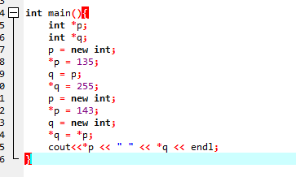

The output = 143 143

B.

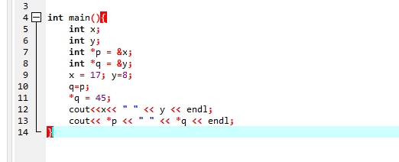

The output = 45 8

45 45

1. A.

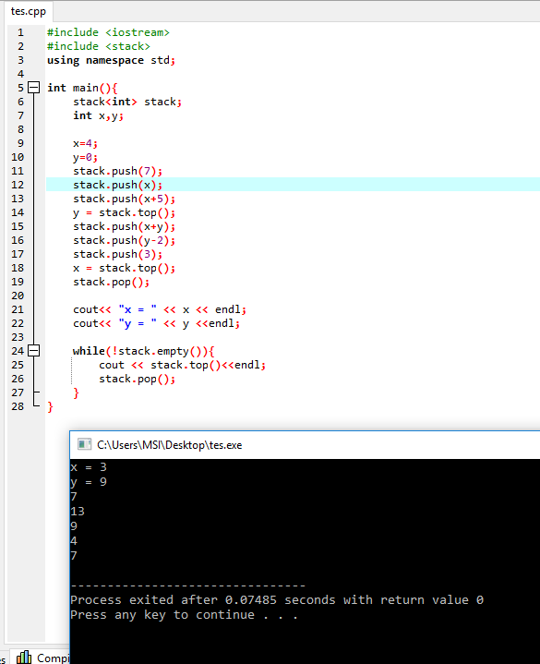

B.

a. (A + B) \* (C + D) – E

-> AB+CD+\*E-

b. A – (B + C) \* D + E / F

-> ABC+D\*-EF/+

c. ((A + B) / (C - D) + E) \* F – G

-> AB+CD-/E+F\*G-

d. A + B\* (C + D) – E / F\* G+H

-> ABCD+\*+EF/G\*-H+

1. A.

10 18 13

B.

a) 18

b) 32

c) 25

d) 23

e) NULL

1. a. line 4

b. line 6

c. valid, Value = 0

d. valid, value = 15

e. its invalid, INFINITE LOOP